%1)

>> x_co=[1,2,3,4,5,6,7,8,9,10]

x_co =

1 2 3 4 5 6 7 8 9 10

>> y_co=[2,5,6,7,8,10,13,15,18,19]

y_co =

2 5 6 7 8 10 13 15 18 19

>> plot(x_co,y_co)

%ans

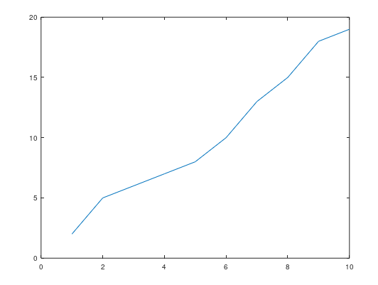

%2)

p = plot(x_co, y_co, ':or', ...

'LineWidth', 2,...

'MarkerEdgeColor', 'g',...

'MarkerFaceColor', 'y',...

'MarkerSize', 12);

%ans

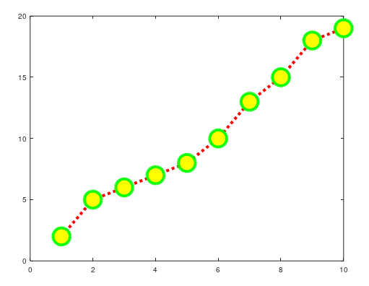

%3)

>> X=[-2:0.01:4]

>> fplot('(3.5^-0.5*X)*cos(6*X)',[-2,4])

%ans

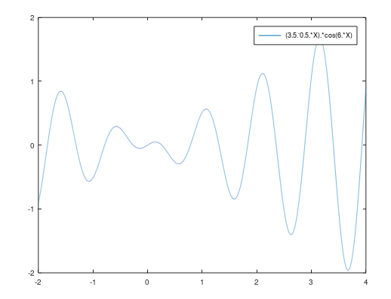

%4)

>> x=1:1:10

x =

1 2 3 4 5 6 7 8 9 10

>> plot(x,power(x,2))

%ans

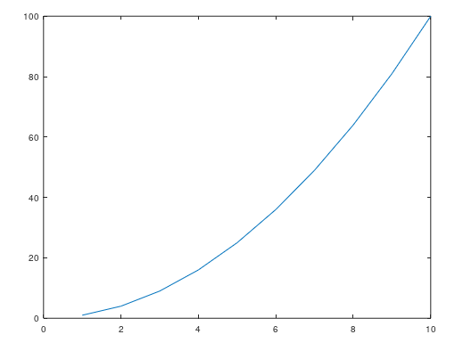

>> plot(x,power(x,3))

%ans

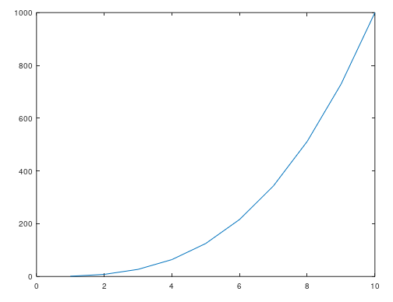

>> plot(x,ln(x))

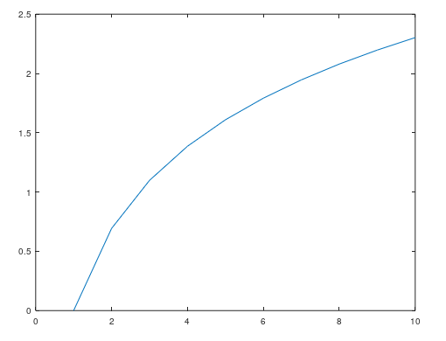

>> plot(x,power(x,-1))

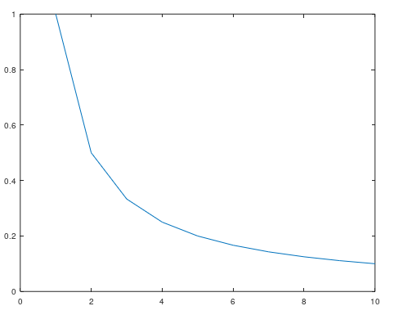

%4)

>> fplot(@(x) sin(x),[0 pi])

%ans

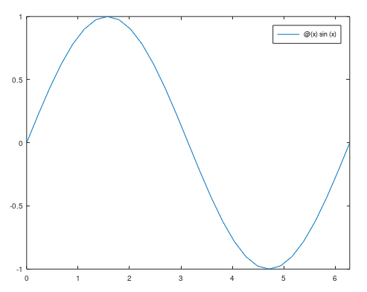

>> fplot(@(x) cos(x),[0 pi])

%ans

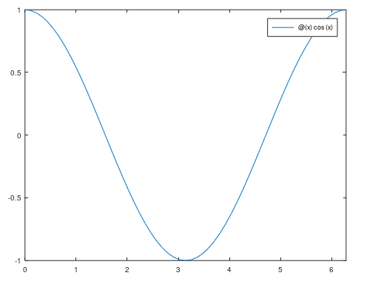

>> fplot(@(x) tan(x),[0 2*pi])

%ans

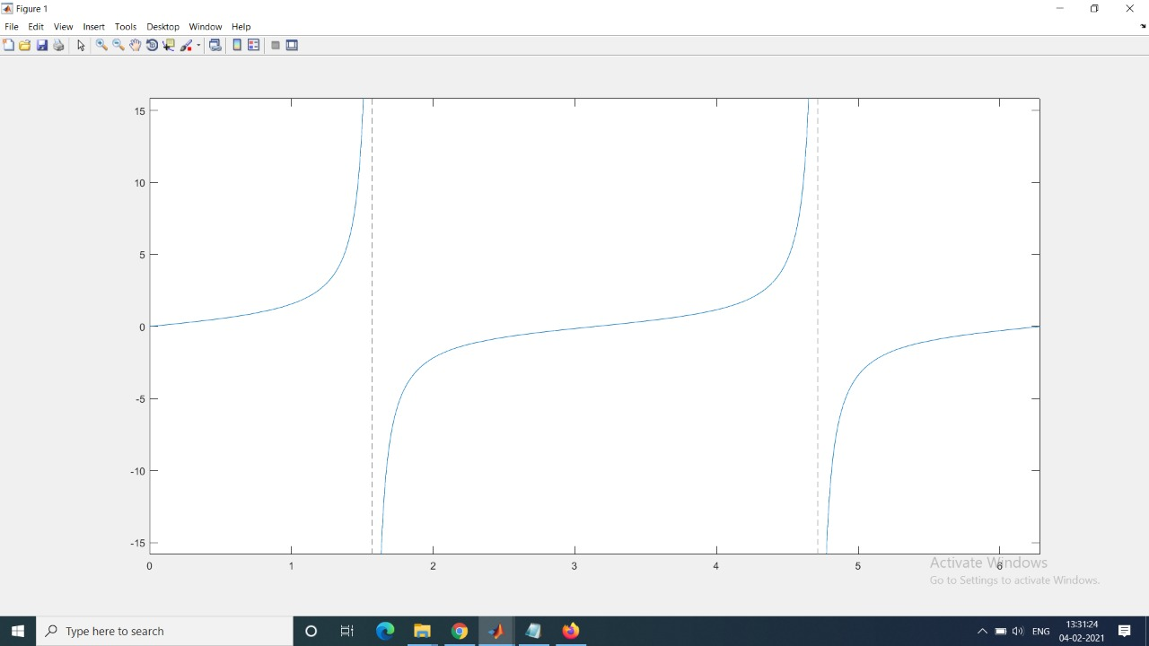

%6)

>> fplot(@(x)(x+5)^2/(4+3*x^2),[-3,5])

%ans

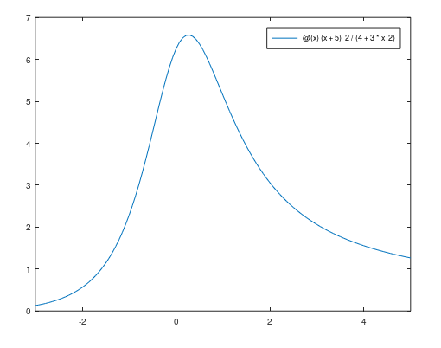

%7) diff

>> x = linspace(-2,4);

>> y = 3*power(x,3)-26*x+10;

>> f1x = diff(y);

>> f2x = diff(f1x);

>> vec_1 = x(1:end-1);

>> vec_2 = x(1:end-2);

>> plot(x,y,vec_1,f1x,vec_2,f2x)

>>x=-2:0.01:4;

>>y=3*x.^3 - 26*x + 10;

>>yd=9*x.^2 - 26;

>>ydd=18*x;

>>plot(x,y,x,yd,x,ydd)

%ans

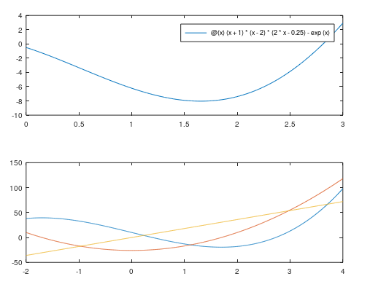

%8) diff

>> x = linspace(-2,4);

>> y = 3*power(x,3)-26*x+10;

>> f1x = diff(y);

>> f2x = diff(f1x);

>> vec_1 = x(1:end-1);

>> vec_2 = x(1:end-2);

>> plot(x,y);

>> hold on

>> plot(vec_1,f1x)

>> hold on

>> plot(vec_2,f2x)

>> hold off

>>x=-2:0.01:4;

>>y=3*x.^3 - 26*x + 10;

>>yd=9*x.^2 - 26;

>>ydd=18*x;

>>plot(x,y)

>>hold on

>>plot(x,yd)

>>hold on

>>plot(x,ydd)

>>hold off

%ans)

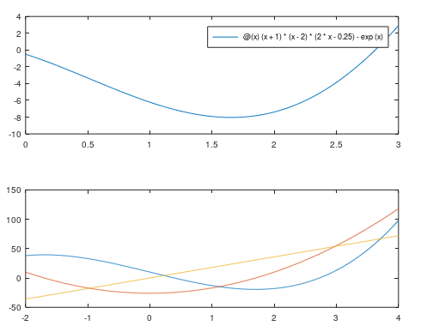

%9)

>> x = linspace(-2,4);

>> y = 3*power(x,3)-26*x+10;

>> vec_1 = x(1:end-1);

>> vec_2 = x(1:end-2);

>> f1x = diff(y);

>> f2x = diff(f1x);

>> vec_1 = x(1:end-1);

>> vec_2 = x(1:end-2);

>> x1=[x vec_1 vec_2];

>> z=[y f1x f2x]

>> line(x1,z)

%ans)

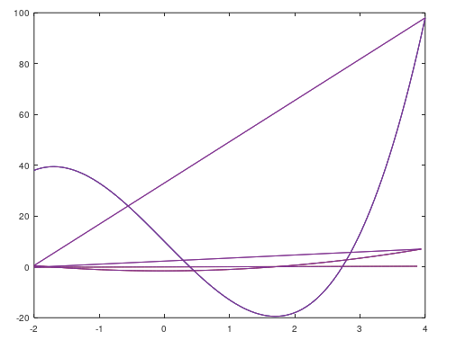

%10)

>>x=10:0.1:22;

>>y=95000./x.^2;

>>xd=10:2:22;

>>yd=[950 640 460 340 250 180 140];

>>plot(x,y,'-','LineWidth',1.0)

>>xlabel('DISTANCE (cm)')

>>ylabel('INTENSITY (lux)')

>>title('Light Intensity as a Function of Distance','FontSize',14)

>>axis([8 24 0 1200])

>>text(14,600,'Comparison between theory and >>experiment.','EdgeColor','r','LineWidth',2)

>>hold on

>>plot(xd,yd,'ro--','linewidth',1.0,'markersize',10)

>>legend('Theory','Experiment')

>>hold off

%ans)

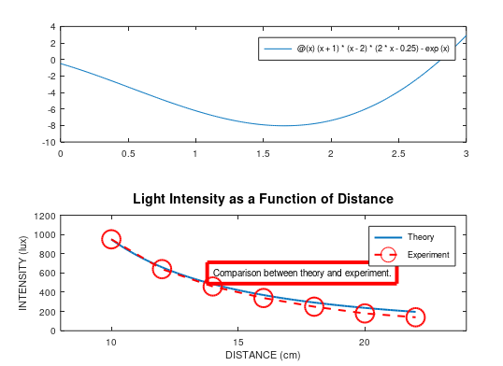

%11)

>> x = 1:0.01:10;

>> subplot(2, 2, 1);

>> plot(x, x.^2)

>> subplot(2, 2, 2);

>> plot(x, x.^3)

>> subplot(2, 2, 3);

>> plot(x, log10(x))

>> subplot(2, 2, 4);

>> plot(x, 1./x)

%ans)

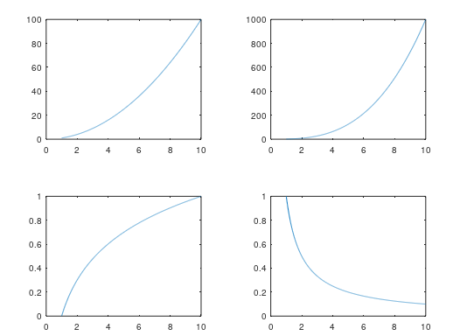

%12)

y = @(x)(x+1)*(x-2)*(2*x-0.25) - exp(x);

subplot(2,1,1);

fplot(y,[0 3]);

subplot(2,1,2);

fplot(y,[-3 6])

%ans)

